Group member names: Michael Eastman, Alexander Overly, Mitchell Whyte, Maurice Taylor, Narbada Acharya

**Exercise 4: Problem Solving** (10 points)

**Instructions:**

1. This is a group assignment. You only need to submit one solved exercise per group.
2. Provide your responses on this file, save it, and upload the file to the appropriate assignment response in blackboard.
3. You may upload as many attempts as you may like. Please note that only the most recent file uploaded file would be graded.
4. Do not handwrite any responses.
5. If you have any additional information you would like me to know about this assignment, you may provide that to me at the end of this document as a note.

**Use the table presented below to answer the following three questions:**

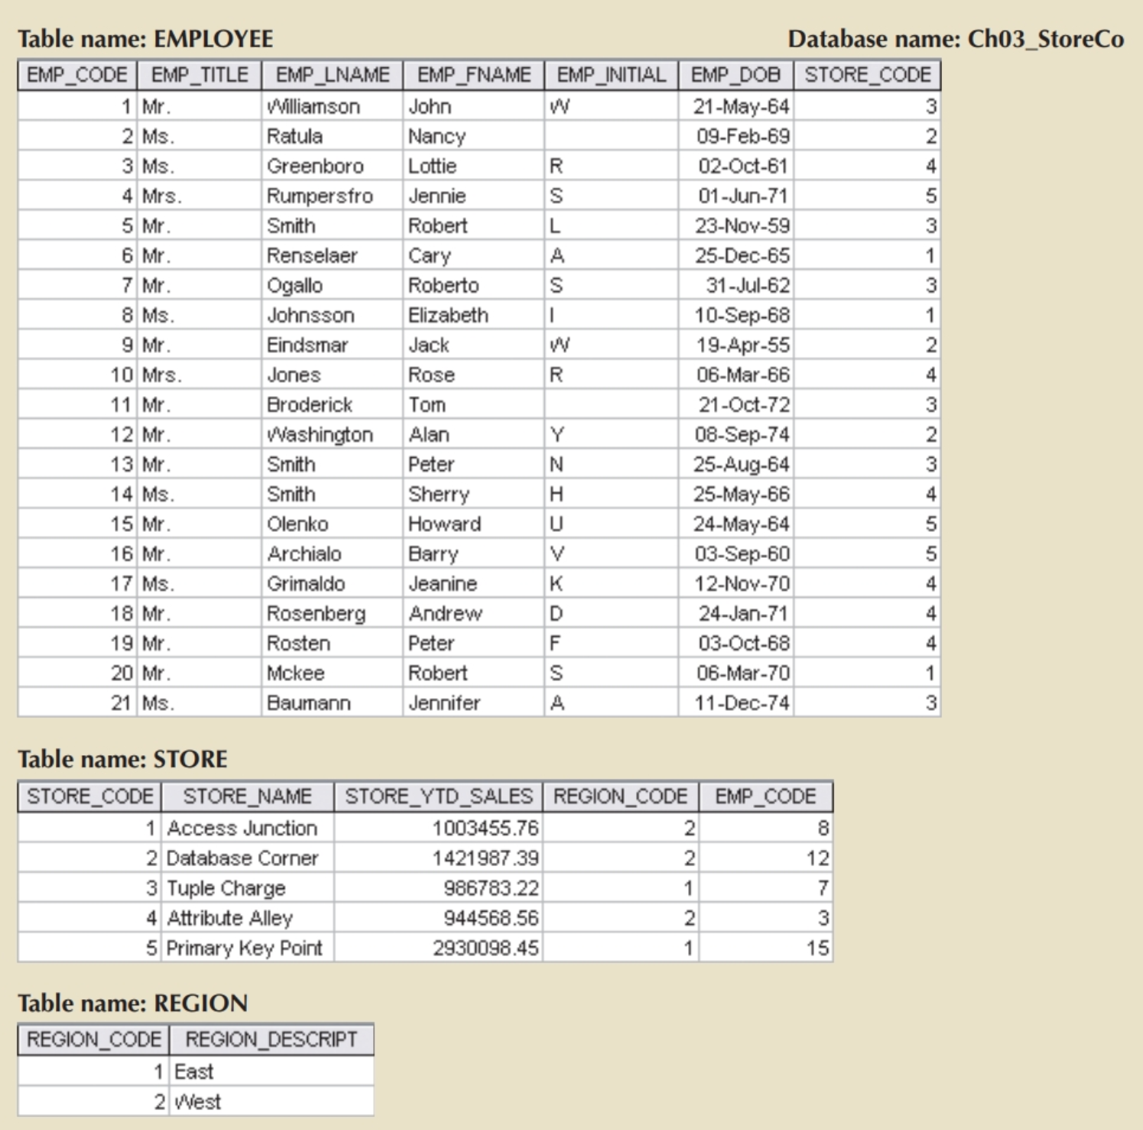

1. **For each table, identify the primary key and the foreign key(s). If a table does not have a foreign key, write *None* in the space provided. Use only the table provided below.**

|  |  |  |
| --- | --- | --- |
| **TABLE** | **PRIMARY KEY** | **FOREIGN KEY(S)** |
| EMPLOYEE | **EMP_CODE** | **STORE_CODE** |
| STORE | **STORE_CODE** | **REGION_CODE, EMP_CODE** |
| REGION | **REGION_CODE** | **NONE** |

**2. Write the business rules for the relationships you identify in #1 above.**

**a. Employee table)** EMP_CODE is only column that ensures data is unique and has no null values. STORE_CODE is the link connecting EMPLOYEE table to STORE table.

**b. Store table)** STORE_CODE contains unique data and is the link connecting EMPLOYEE and STORE tables. REGION_CODE connects STORE and REGION tables. EMP_CODE connects the STORE and EMPLOYEE tables.

**c. Region table)** REGION_CODE contains unique values, not descriptions, for each row. There is no foreign key, as REGION_DESCRIPT does not connect any two tables to each other.

**3. Create a Visio ERD for the database in Figure. Copy paste the Visio ERD below.**

